**Import Asset/Deferred Expense**

Module: goexcel_import_asset

1. Go to Asset/Deferred Expense. Click Import

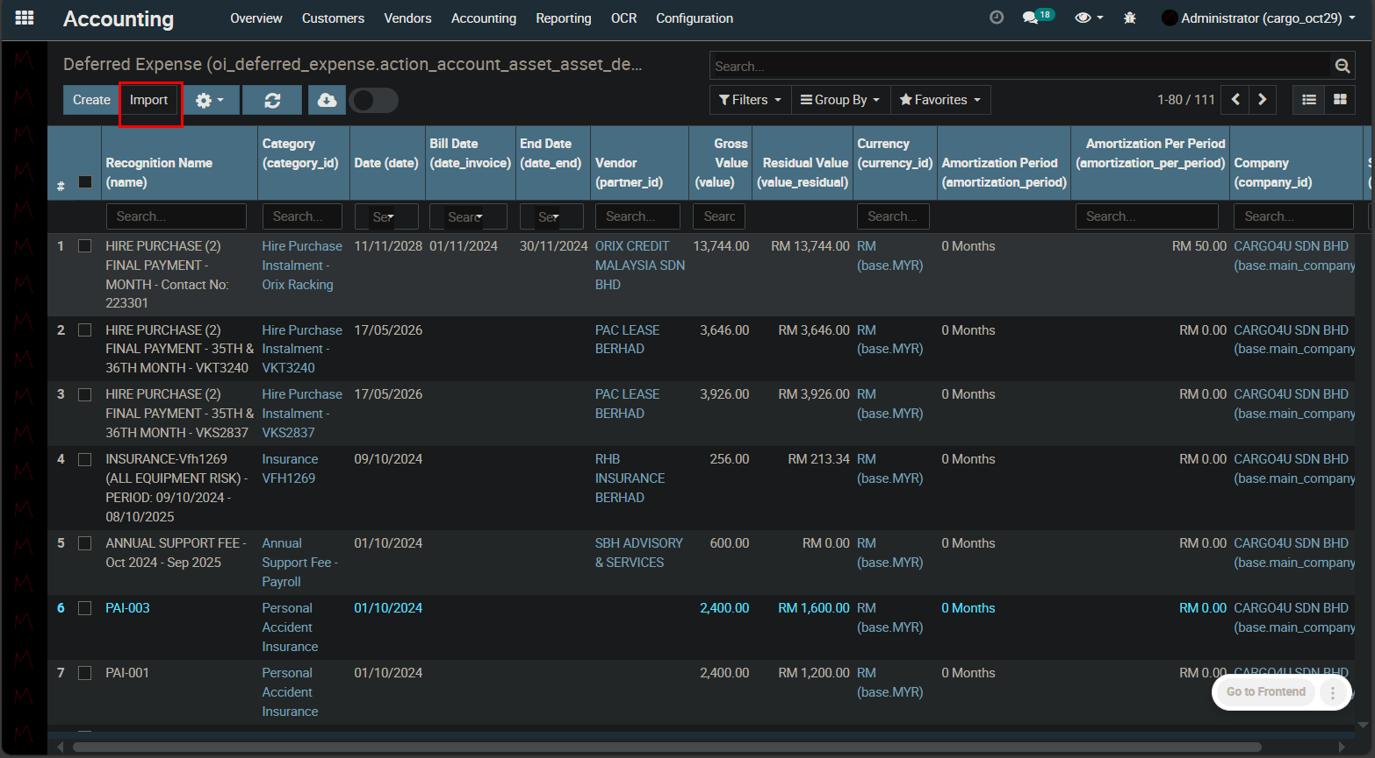

1. Download template accordingly

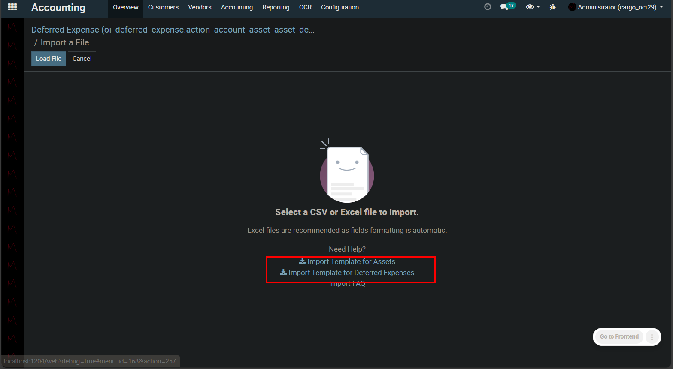

1. Fill in the values in the imported Excel sheet.

For import existing:

Deferred Expense

|  |  |  |
| --- | --- | --- |
| **Already Recognized Amount Import** | **Recognition Number Import** | **First Recognition Date Import** |

Asset

|  |  |  |
| --- | --- | --- |
| **Already Depreciated Amount Import** | **Depreciation Number Import** | **First Depreciation Date Import** |

Fill in for above columns

Already Recognized/Depreciated Amount: Amount already recognized/depreciated for the respective deferred expense/asset in the old system

Recognition/Depreciation Number Import: Number of recognition/depreciation already happened in old system

First Recognition/Depreciation Date Import: Date of first recognition/depreciation done in old system

Date: Should be the starting date of recognition/depreciation in goexel system

Gross Value: Total value of Deferred Expense/Asset (as of old system)

1. Click Load File and upload the edited file back

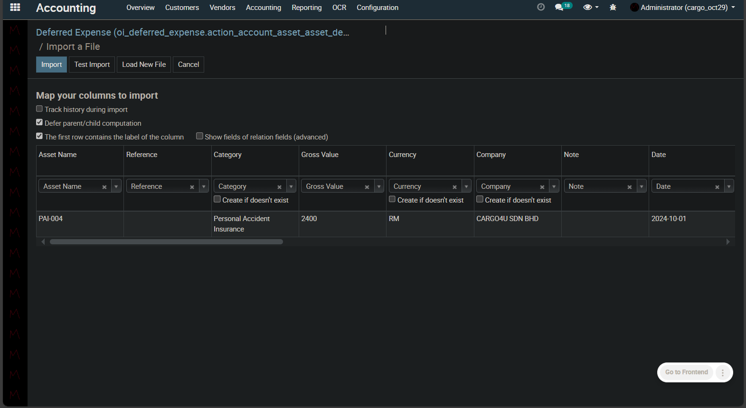

1. Click Import
2. You will see a message X records were successfully imported and wil be redirected to list view

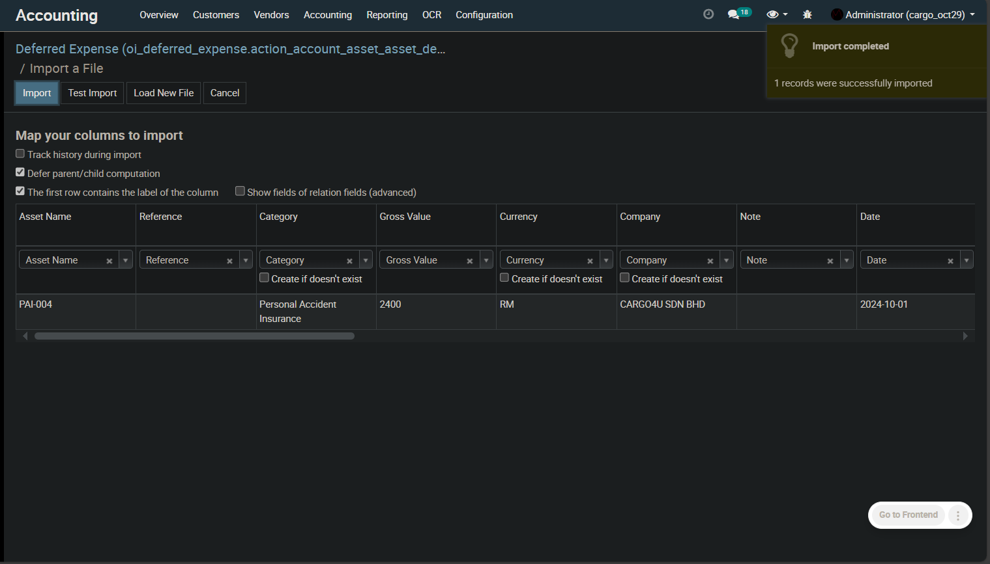

1. Check record

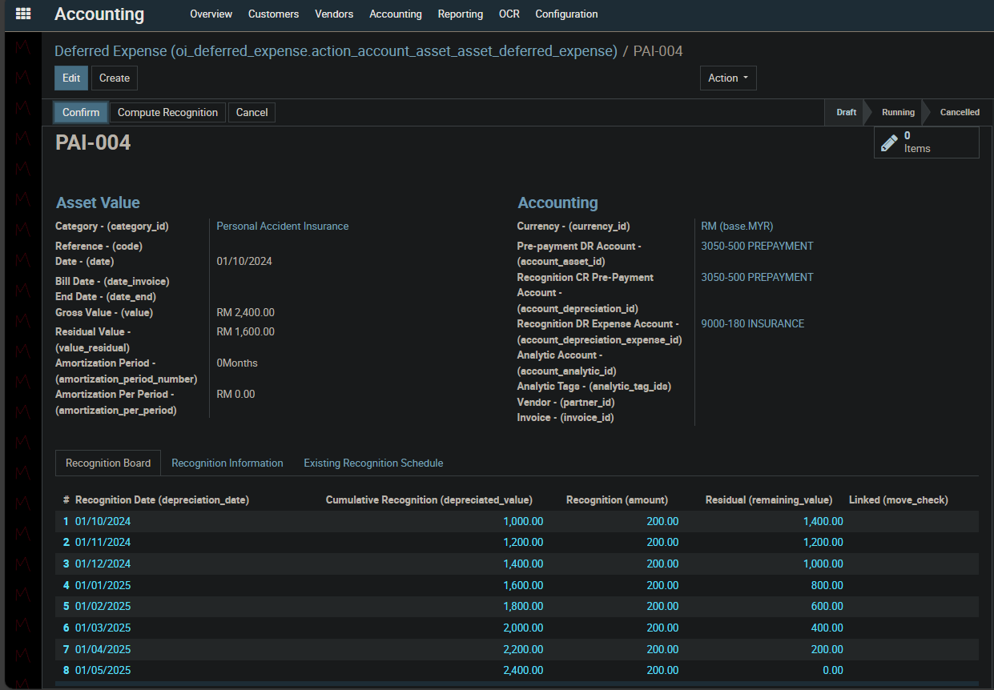

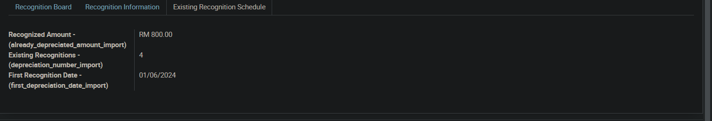

-------DONE--------